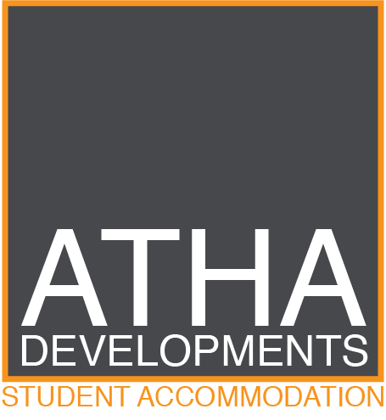
EQUALITY AND DIVERSITY POLICY

Atha Developments is committed to providing a living environment free from discrimination, bullying, harassment or victimisation, where all members of our community are treated with respect and dignity.
Atha Developments are committed to working in an inclusive way with all the communities in which we are geographically located and to developing a student community that reflects the UK’s and Middlesbrough’s diversity and vibrancy.
We intend to promote equality and prevent discrimination through our roles as:
- A student accommodation supplier;
- a potential employer; and
- a community and/or business partner.
We will follow best practice in all equality areas and work to:
- eliminate unlawful discrimination;
- promote equality of opportunity;
- eliminate bullying and harassment;
- promote good relations between different groups;
- celebrate what we have in common and capitalise on our diversity; and
- recognise and take account of people’s differences.
Characteristics protected by equality legislation are:
- age
- disability
- gender reassignment
- marriage/civil partnership
- pregnancy/maternity leave
- race
- religion or belief
- sex
- sexual orientation

However, we recognise that equality issues are complex and straddle more than just those equality strands protected by equalities legislation.
Life circumstances and opportunities also affect us, so we also take account of issues such as:
- cultural and economic background
- physical and social environment
- health

