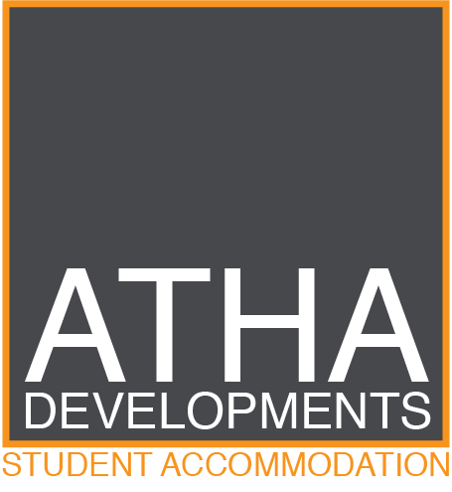
CLEANING INFORMATION

DETAILS OF CLEANING:

The Cleaning Ladies will clean all communal spaces within the building which is included in your rent. This includes:
- Entrance hall and Hallways
- Stairways
- Lift
- All 3 Common Rooms

DATES:

Our cleaners will attend site once a fortnight.

1st and 3rd Monday of the month

CLEANERS DETAILS:

The Cleaners details are:

The Cleaning Ladies
Contact Name: Stacy
Contact Number: 07825 293638

UPGRADE OPTIONS:

You can upgrade the cleaning services to include you Studio Apartment. A separate charge will apply, and this can be arranged directly with the Cleaning Ladies.

